MINOR PROJECT

**Project 2:**

Implementation of a Bluetooth controlled Robotic Car:

Using a 2/4 Wheel chassis control the robotic car with a wireless network.

(No restriction upon movement).

Challenge (Optional)

Get the wireless data transmitted back and displayed on the application (e.g.: Temperature Sensor)

**REQUIRED COMPONENTS:**

* Arduino UNO with cable
* Bluetooth module HC-05
* Motor Driver L293D
* Two-wheel robot chassis
* Two DC motor
* Jumper wires
* Mini breadboard
* 9V battery (Power bank)
* 2 battery clip connectors (1 connector must be suitable with DC jack on Arduino)
* Speed sensor with encoder wheel

**Android controlled Arduino robot car**  make use of an Android mobile phone for robotic control with the help of HC-05 Bluetooth technology. This is a simple robotics projects using Arduino microcontroller. This project is Bluetooth controlled robot. For this the android mobile user has to install an application on her/his mobile. This android application could be downloaded in the android market.

Then user needs to turn on the Bluetooth in the mobile. The wireless communication techniques used to control the robot in Bluetooth technology. User can use various commands like move forward, reverse, stop move left, move right. These commands are sent from the Android mobile to the Bluetooth receiver which is interfaced with the Arduino robot.

**Android based robot** has a HC-05 Bluetooth receiver unit which receives the commands and give it to the microcontroller circuit to control the motors. The microcontroller then transmits the signal to the motor driver IC’s to operate the motors.

Default baud rate of new Bluetooth module is 9600 bps. You just need to connect Rx and Tx to controller or serial converter and give 5 Volt dc regulated power supply to module.

Bluetooth module has two modes one is master mode and second one is slave mode. User can set either mode by using some AT commands. Even user can set module’s setting by using AT command.

First of all, user need to enter AT mode with 38400 bps baud rate by pressing EN button at Bluetooth module or by giving HIGH level at EN pin.

After it if you send AT to module then module will respond with OK

AT → Test Command

AT+ROLE=0 → Slave Mode select

AT+ROLE=1 → Master Mode select

AT+NAME=xyz → Set Bluetooth Name

AT+PSWD=xyz → Set Password

AT+UART=<value1>, <value2>, <value3> → set Baud rate

E.g. AT+UART=9600,0,0

1. STATE → Open
2. Rx → Serial receiving pin
3. Tx → Serial transmitting pin
4. GND   → ground
5. Vcc     → 9-volt dc
6. EN       → to enter in AT mode

**CIRCUIT DIAGRAM:**

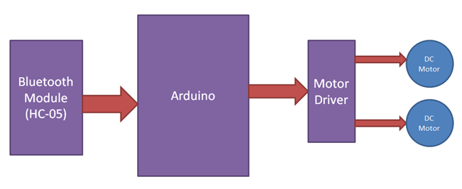

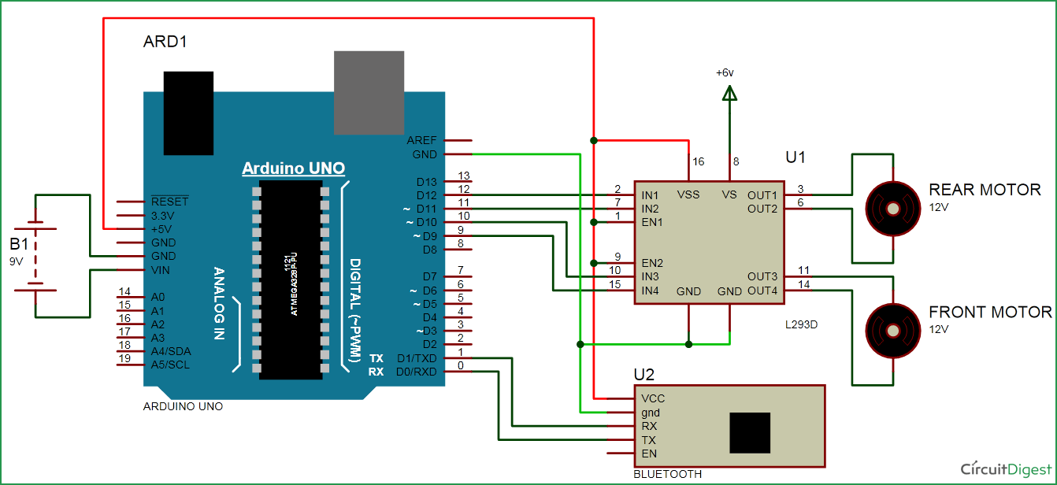

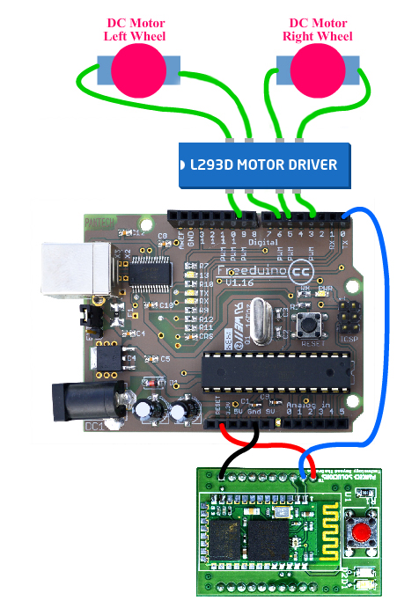

**Explanation of circuit diagram**

A Motor driver is connected to Arduino to run the robotic car. Motor driver’s input pins 2, 7, 10 and 15 are connected to Arduino’s digital pin number 12, 11, 10 and 9 respectively. We have used two DC motors to driver car in which one motor is connected at output pin of motor driver 3 and 6 and another motor is connected at 11 and 14. Bluetooth module’s Rx and Tx pins are directly connected at Tx and Rx of Arduino.

In this project we have made a Bluetooth controlled robotic car. This car has two dc motors at its front and rear side. Front side motor is used for giving direction to car means turning left or right side (like real car steering feature). And rear side motor is used for driving the car in forward and backward direction. A Bluetooth module is used to receive command from android phone and Arduino UNO is used for controlling the whole system.

Bluetooth controlled car moves according to button touched in the android Bluetooth mobile app. To run this project first we need to download Bluetooth app form Google play store. We can use any Bluetooth app that supporting or can send data.

- Bluetooth controller

After installing app, we need to open it and then search Bluetooth device and select desired Bluetooth device. And then configure keys.

1. Download and install Bluetooth Controller.
2. Turned ON mobile Bluetooth.
3. Now open Bluetooth controller app
4. Press scan
5. Select desired Bluetooth device
6. Now set keys by pressing set buttons on screen.

When we touch forward button in Bluetooth controller app the car start moving in forward direction and continues to move forward until next command comes.

When we touch backward button in Bluetooth controller app then car start moving in reverse direction and moving continues reverse until next command comes.

When we touch left button in Bluetooth controller app then car start moving in left direction and moving continues left until next command comes. In this condition front side motor turns front side wheels in left direction and rear motor runs in forward direction.

When we touch right button in Bluetooth controller app then car start moving in right direction and moving continues right until next command comes. In this condition front side motor turns front side wheels in right direction and rear motor runs in forward direction.

And by touching stop button we can stop the car.

|  |  |  |  |  |  |
| --- | --- | --- | --- | --- | --- |
| **Touched button in Bluetooth controller app** | **Output for front side motor to give direction** | | **Output for rear side motor to move forward or reverse direction** | |  |
| **Button** | **M11** | **M12** | **M21** | **M22** | **Direction** |
| Stop | 0 | 0 | 0 | 0 | Stop |
| Forward | 0 | 0 | 0 | 1 | Forward |
| Backward | 0 | 0 | 1 | 0 | Backward |
| Right | 1 | 0 | 0 | 1 | Right |
| left | 0 | 1 | 0 | 1 | Left |

**Code for the above process**

#define M11 11    // rear motor  
#define M12 12  
#define M21 10    // front motor  
#define M22 9

char str[2], i;

void forward() //move forward(all motors rotate in forward direction)  
{  
   digitalWrite(M11, LOW);  
   digitalWrite(M12, LOW);  
   digitalWrite(M21, HIGH);  
   digitalWrite(M22, LOW);  
}

void backward() //move reverse (all motors rotate in reverse direction)  
{  
   digitalWrite(M11, LOW);  
   digitalWrite(M12, LOW);  
   digitalWrite(M21, LOW);  
   digitalWrite(M22, HIGH);   
}

void left() //turn right (left side motors rotate in forward direction, right side motors doesn't rotate)

{  
   digitalWrite(M11, HIGH);  
   digitalWrite(M12, LOW);  
   delay(100);  
   digitalWrite(M21, HIGH);  
   digitalWrite(M22, LOW);  
}

void right() //turn left (right side motors rotate in forward direction, left side motors doesn't rotate)

{  
   digitalWrite(M11, LOW);  
   digitalWrite(M12, HIGH);  
   delay(100);  
   digitalWrite(M21, HIGH);  
   digitalWrite(M22, LOW);  
}

void Stop()  
{  
   digitalWrite(M11, LOW);  
   digitalWrite(M12, LOW);  
   digitalWrite(M21, LOW);  
   digitalWrite(M22, LOW);  
}

void setup()   
{  
  Serial.begin(9600);  
  pinMode(M11, OUTPUT);  
  pinMode(M12, OUTPUT);  
  pinMode(M21, OUTPUT);  
  pinMode(M22, OUTPUT);  
}

void loop()   
{  
  while(Serial.available())  
  {  
    char ch=Serial.read();  
    str[i++]=ch;  
      
    if(str[i-1]=='1')  
    {  
     Serial.println("Forward");  
     forward();  
     i=0;  
    }

    else if(str[i-1]=='2')  
    {  
     Serial.println("Left");  
     right();  
     i=0;  
    }

    else if(str[i-1]=='3')  
    {  
      Serial.println("Right");  
      left();  
      i=0;  
    }  
      
    else if(str[i-1]=='4')  
    {  
      Serial.println("Backward");  
      backward();  
      i=0;  
    }

    else if(str[i-1]=='5')  
    {  
      Serial.println("Stop");  
      Stop();  
      i=0;  
    }  
    delay(100);  
  }  
}

**OTHER WAY:**

char t;

void setup()

{pinMode(13,OUTPUT); //left motors forwardpinMode(12,OUTPUT); //left motors reversepinMode(11,OUTPUT); //right motors forwardpinMode(10,OUTPUT); //right motors reversepinMode(9,OUTPUT); //LedSerial.begin(9600); } void loop()

{if(Serial.available())

{ t = Serial.read(); Serial.println(t);} if(t == 'F') //move forward(all motors rotate in forward direction){

digitalWrite(13,HIGH); digitalWrite(11,HIGH);} else if(t == 'B') //move reverse (all motors rotate in reverse direction)

{ digitalWrite(12,HIGH); digitalWrite(10,HIGH);} else if(t == 'L') //turn right (left side motors rotate in forward direction, right side motors doesn't rotate)

{ digitalWrite(11,HIGH);} else if(t == 'R') //turn left (right side motors rotate in forward direction, left side motors doesn't rotate)

{ digitalWrite(13,HIGH);}else if(t == 'W') //turn led on or off

{ digitalWrite(9,HIGH);}else if(t == 'w')

{ digitalWrite(9,LOW);} else if(t == 'S') //STOP (all motors stop)

{ digitalWrite(13,LOW); digitalWrite(12,LOW); digitalWrite(11,LOW); digitalWrite(10,LOW);}delay(100);

}

**SUBMITTED BY: SHREYA KUMARI**

**krshreya2402@gmail.com**